**Site Purpose:**

The purpose is to give the information needed for those going to participate in temple related services. It will give straightforward access to reserving a room or suite and all of the info needed to make that choice. It will also give current weather info and small forecast to help with planning their trip.

**Target Audience:**

The target audience is adults, of all ages, looking for housing or accommodation near the temple they will be attending.

**Site Map:**

Home (Landing page)

* Temples
* Reservation
* Services
  + Receptions
  + Full-time Temple Missionary

**Color Scheme:**

Day/Light Mode Scheme – The day sky for backgrounds, color of earth and grass for foreground, white for fonts

Main Background

*#accce5 – sky blue*

Sub-background

*#374f1b – military green*

Small Main Highlights

*#d27452 – pumpkin orange*

*#52415b – purple olive*

Sub-highlights

*#3c94be – almost blue*

Text

*Black on light colors*

*White on dark colors*

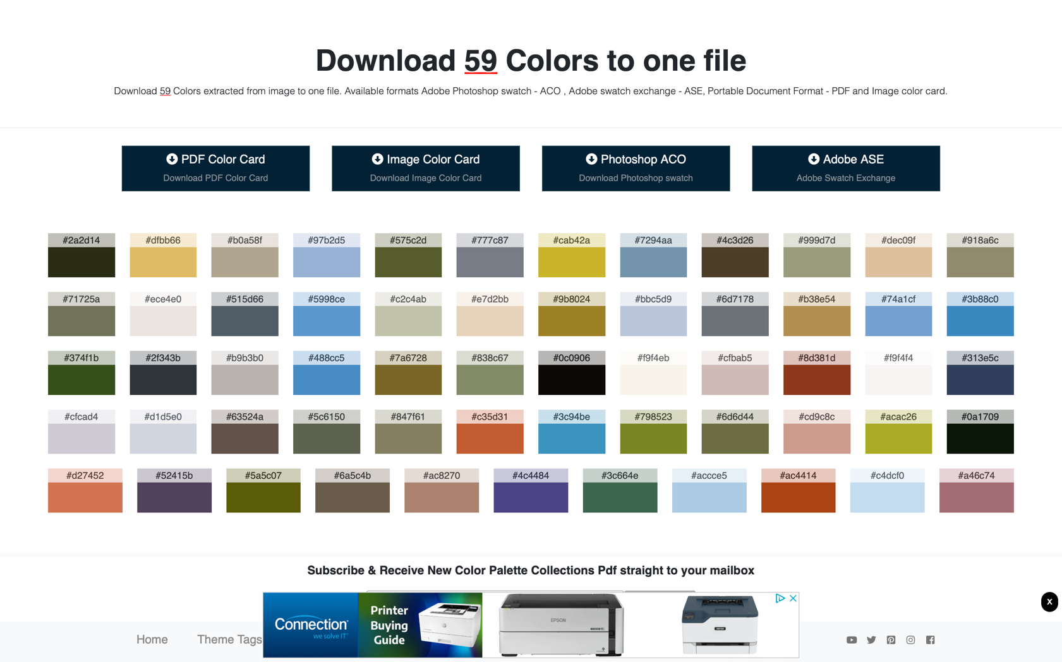

**Typography:**

Header Fonts – *Lora* – just a little fancy, yet super readable. Most important thing with headers is that they can be read on the way to the content. Should be the easiest thing on the page to read besides images.

Fancy Header - *Monsieur La Doulaise* – Fancy and requires a little more focus to read than usual which will allow it to make an impact in SMALL doses

Main Body Font – *Poppins* – A simple Sans-Serif font can go a long way, and since there will be a lot of text on these pages, this is exactly what we needed.

**Wireframe Sketches:**

Small:

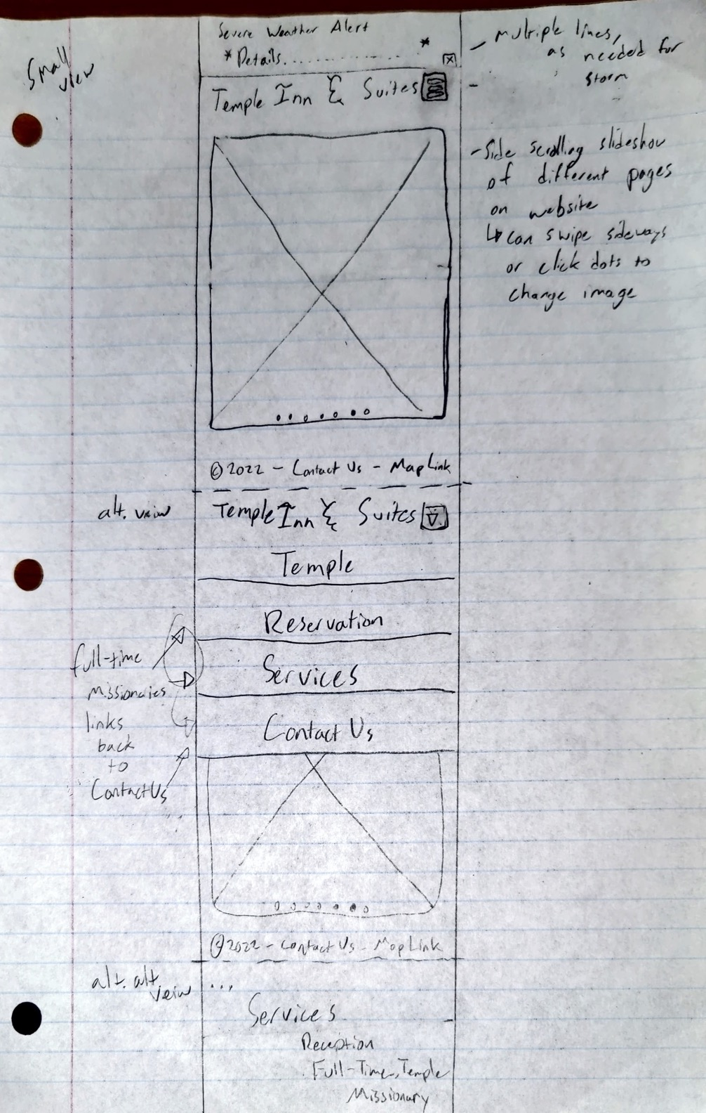

Medium:

Large:

Home (Landing page)

Rooms, Suites, and Availability (interactive search bar and filtered list)

* + Individual Room or suite info
  + Booking a room or suite
* Local Attractions (besides the temple what is there to do w/links)
* Contact Us (Questions and general contact info)

Night/Dark Mode Scheme – The night sky for backgrounds, color of celestial comets and stars for foreground, a light metallic matte color for the text